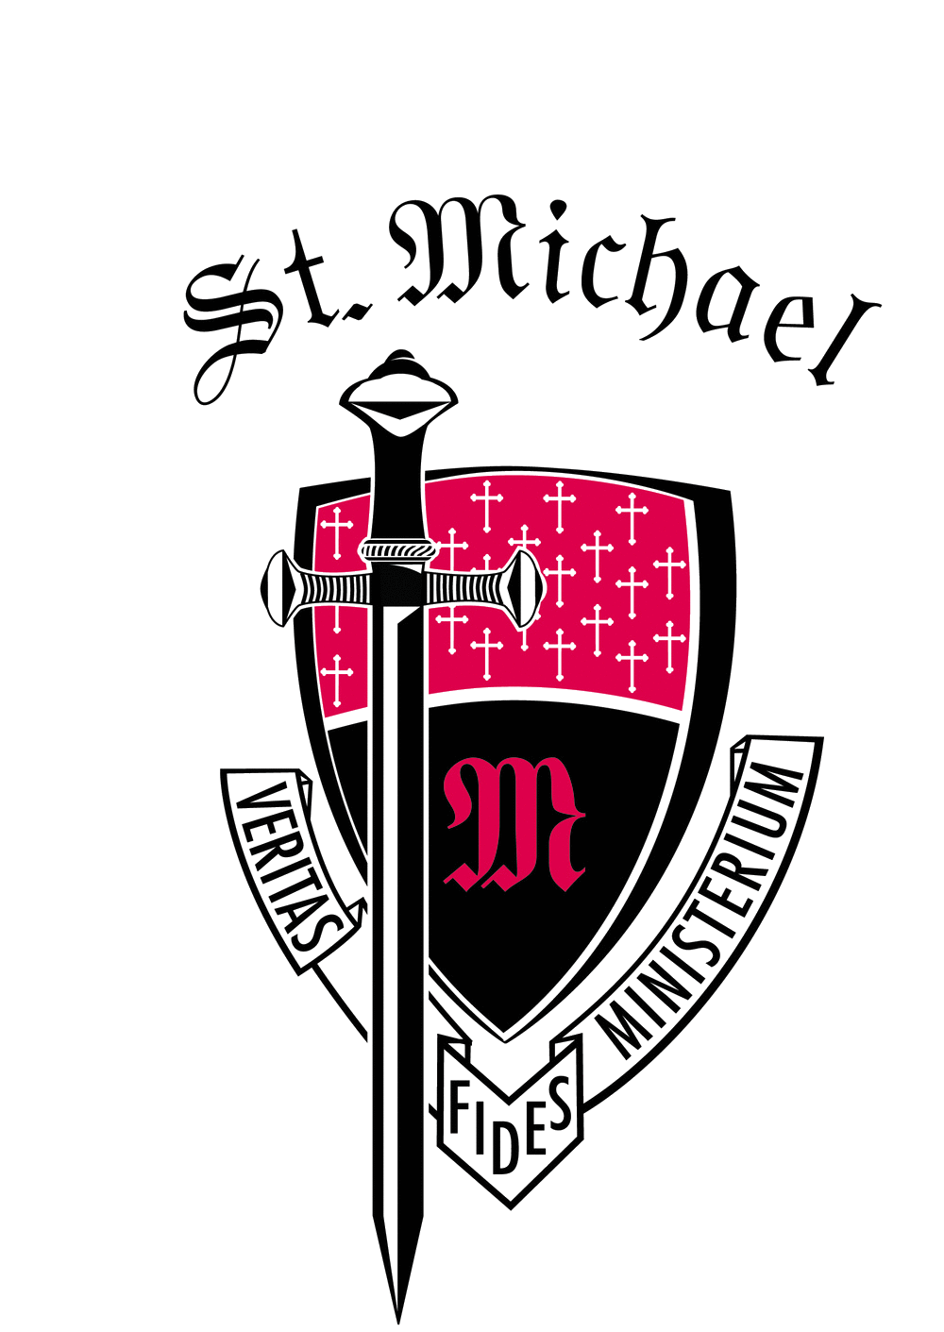
St. Michael the Archangel High School
Tuition Assistance Information
2023 – 2024 School Year
New Students

Please note that all Red, bold, and underlined font are links that will take you to additional information.

Tuition Assistance Applications are accepted now through March 31, 2023 in FACTS.
- We encourage all families that are concerned about the accessibility of St. Michael to apply for tuition assistance.
- Families applying for tuition assistance will need to complete the FACTS application online, pay the $40.00 fee online and submit the necessary supporting documentation to FACTS by March 31, 2023.
- FACTS uses a standardized method of evaluation to review submitted applications and then provides a confidential report to St. Michael High School. The St. Michael Tuition Assistance Committee will review the report along with submitted applications to award tuition assistance.
- Questions or concerns about Tuition Assistance should be directed to Susan Thibodeaux, Finance.

The Diocese of Baton Rouge Catholic School’s Office offers tuition assistance via the Bishop’s Annual Appeal and the Black and Indian Mission Funds.

Families may also be eligible to apply for the ACE Scholarship.
- Applications open on March 1, 2023.

In addition to Tuition Assistance, St. Michael has Scholarship Opportunities for admitted incoming freshman students. The applications are open from late February and are due by April 30, 2023.
• St. Michael High School Foundation Scholarship sponsored by the Warrior Club
• St. Michael High School Leadership Scholarship
• Matthew Guillot Memorial Band Scholarship
• Jake T Ragusa Scholarship

