

ST. MICHAEL THE ARCHANGEL   
**Diocesan Regional Catholic High School  
www.smhsbr.org**

Uniform Footwear for the 2024-2025 School Year

Tennis shoes may be worn with the daily wear uniform. Tennis shoes must be a traditional low quarter style with shoe laces. The shoe color must be black, gray, or white or a combination of these colors. Trim color must be black, gray, or white. No metallic, shiny, or fluorescent colors and no patterns such as plaid, checks, or polka dots are allowed. The laces and the soles must be in the same color scheme (black, gray, white) and traditionally tied. Soles must be of regular thickness; no platform soles.

On dress uniform days, students will be required to wear black leather, tie up or slip on, low quarter shoes below the ankle. Laces must always be tied. Shoes must be worn properly without stepping on the back of the shoes. Tennis shoe passes will not be issued for dress uniform days. The dress uniform shoes may be worn with the daily uniform.

Neither shoe needs to be an expensive choice. There are many reasonably priced shoes that fit the requirements of both the tennis shoes and the dress uniform shoes.

If you have any questions or are unsure of what is acceptable concerning uniform footwear or uniforms in general, please contact SMHS Dean of Students, Mr. Kegan Keller. His email is [kkeller@smhsbr.org](mailto:kkeller@smhsbr.org).

Examples of Acceptable Footwear:

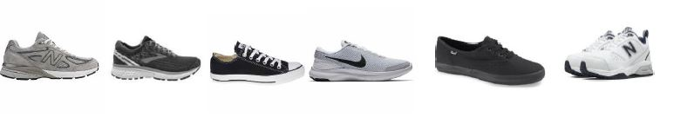  
Examples of Unacceptable Footwear:

